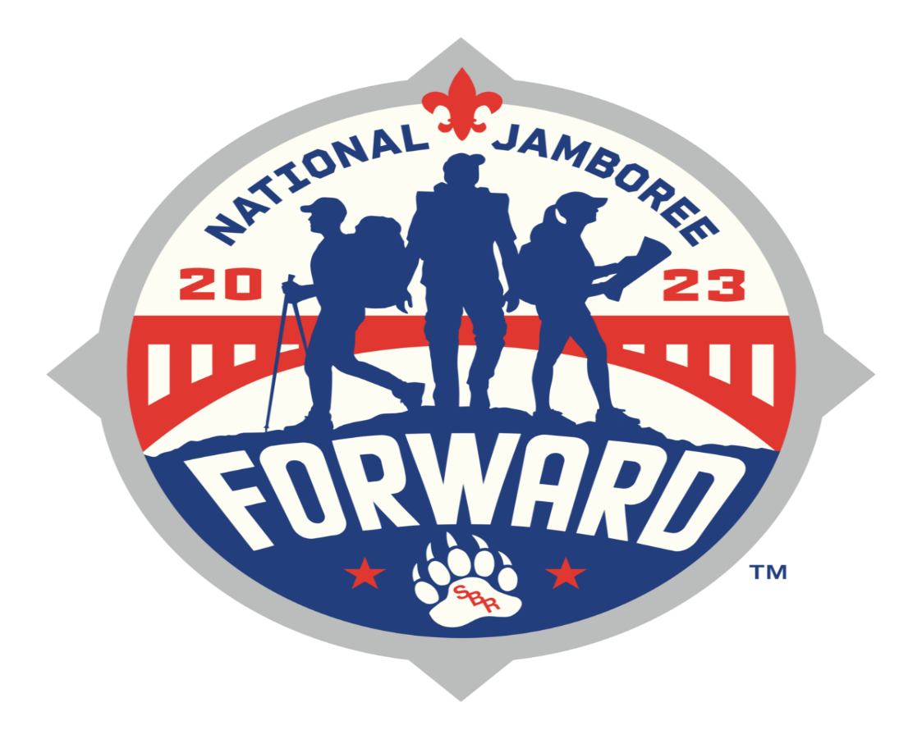

A Guide for
Participants & Parents
WEST TENNESSEE AREA COUNCIL CONTINGENT
2023 National Jamboree
Summit Bechtel Reserve
July 19-28, 2023

January 5, 2023
West Tennessee Area Council
Boy Scouts of America
1995 Hollywood Drive
Jackson, TN 38305

Participants and Parents,
On behalf of the West Tennessee Area Council, welcome to the 2023 National Jamboree Contingent!
My name is Misty Croom, District Executive for the Central District, and I’m delighted to serve as your Council Staff Adviser for the 2023 National Jamboree. In my role as Staff Adviser, I work alongside our Council Contingent Leadership to ensure participants are prepared to attend the 2023 National Jamboree. The more prepared you are, the more fun you’ll have!
Unfortunately, we are starting this process a little late in the game. However, with your patience, support, and open communication we can guarantee a successful trip to Jamboree!
Please note this packet is designed to provide an overview to guide participants and parents. We are in the early stages of our preparation for the 2023 National Jamboree so this is NOT intended to be all the information a participant will need. As you have questions or concerns, it will be up to you to communicate those with your Contingent Leadership and find an answer or resolution.
I thank you for this opportunity to serve as your Council Staff Adviser for the 2023 National Jamboree.
Forward to Jambo!
Misty Croom
Misty Croom
Council Staff Advisor

Contents
Communication & Updates 5
Email Updates 5
Social Media 5
Helpful and Friendly Contacts 5
West Tennessee Area Council 5
Volunteer Contingent Leaders 5
Cost & Payments 6
Council Contingent Fees and Refunds 6
2023 National Jamboree Fee and Refund Policies 6
Council Contingent Fee 6
The Council Contingent Participant Fee includes: 6
Council Refund Policy 7
Key Dates & Planning Calendar 7
January 2023 7
February 2023 7
March 2023 7
April 2023 7
May 2023 7
June 203 7
July 2023 7
Program at the Jamboree 8
Adventure Areas 8
Jamboree Trek / Leadership Challenge 8
Aquatics Program and Swim Classifications 9
Religious Observances 9
Service Projects For 2023 9
Visitors 9
Base Camp, Subcamp & Unit Operations 9
Unit Campsite Configuration 10
Base Camp and Sub Camp Operations 11
Transportation 11
Lost and Found 11
Gear & Equipment 11
Personal Gear 11
Clothing 11
Optional 12
Sustainability 12
Cooking and Eating 12
Duties will include: 12
Menu 13
Cooking Equipment 13
Special Diets 13
Medical Requirements 13
Physical Examination 13
Immunizations 14
Exceptions to Immunization on Medical or Religious Grounds 14
Physical Fitness— 14
Medications 15
Staff a.k.a. Jamboree Service Team 15
Statement of Understanding 15
Code of Conduct 16
Youth Protection 17
Commitment to Safety 17
Unit Organization 18
Scouts BSA Organization 18
Adult Participant Roles 18
Youth Participant Roles 20
Postal Service 21
Trading Posts & Retail 21
Telephone Communications 22

Communication & Updates
The national staff for the jamboree is continually providing updates to council contingents as they work towards their plan. Please be patient, as we get closer to the event, we have planned communication releases that will be sent out to keep you informed.

Email Updates
Know that we will continue to update participants using the “Preferred email address” which you provided on the registration page.

Social Media
We will regularly update the Facebook Page. Facebook page: WTAC 2023 National Jamboree

Helpful and Friendly Contacts

West Tennessee Area Council
Staff Adviser: Will keep you moving FORWARD on this adventure to Jamboree.
Misty Croom 731-234-5986 misty.croom@scouting.org
Registrar and Financial: Will make sure you’re registered and will assist you with your payments.
Susan Gall 731-668-3787 susan.gall@scouting.org
Scout Shop: Get your full Field Uniform, Camping gear, and all other scouting needs.
Jenise Smith 731-668-3787 jenise.smith@scouting.org

Volunteer Contingent Leaders

Male Leaders
Scout Master: John Lewter
Assistant Scout Master: __________________
Female Leaders:
Scout Master: Annette Luttrell - Unit Care Provider
Assistant Scout Master 1 – Ashlee Starkey
Assistant Scout Master 2- Lacey Cunningham

Cost & Payments

Council Contingent Fees and Refunds
Individual fees for Council Contingent members as well as deposit requirements and fee payment schedules are set by local councils.
The national fee set by Jamboree Administration covers the expense of program materials, food, insurance, and equipment, as well as the use of dining shelters, stoves, fuel, and cooking utensils.
All questions/concerns regarding the fees of an individual member of a council contingent should be addressed to the local council.

2023 National Jamboree Fee and Refund Policies

Individual participant Jamboree fees have been established for the 2023 National Jamboree to be held at The Summit Bechtel Family National Scout Reserve as follows:
- Youth, Young Adults, and Leader participants registered ON or BEFORE October 31, 2022 – $1,285
- Youth, Young Adults, and Leader participants registered ON or AFTER November 1, 2022 – $1,500
Effective November 1, 2022, the price for a Contingent member registering for the Jamboree will increase to $1,500 (14% or $215) due to economic conditions such as fuel, food, and supply issues. It is strongly recommended that Councils modify their advertised pricing to reflect this change. The payment plan is being revised and should allow both BSA Members and Councils additional time to transition member payments to councils and council payments to the Jamboree.

Council Contingent Fee
The Council Contingent Participant fee (which includes the National Jamboree Fee) is set at $2400 for those registered prior to November 1 , 2023 and $2615 for those registered after November 1, 2022 and is due in full by May 1st, 2023.
The payment schedule plan is as follows: Registered prior to November 1, 2022
January 15th $480 February 15th $480 March 15th $480 April 15th $480 May 15th $480
The payment schedule plan is as follows for those who registered AFTER November 1, 2022
January 15th $523 February 15th $523 March 15th $523 April 15th $523 May 15th $523

The Council Contingent Participant Fee includes:

- All preparation events
- Transportation to and from the Jamboree Site
- Use of Tent, Cot, & Unit Gear
- Food
- 2023 Jamboree WTAC Council Duffel Bag
- 2023 Jamboree Day bag
- 2023 Jamboree Council Contingent T-Shirts
- 2023 Jamboree hat
- 2 – 2023 Jamboree Participant Patches
- 2 – Council Strip Patches specially designed for the 2023 National Jamboree
- Unit Number Patch (for your Jamboree unit)
- 2023 National Jamboree Name Tag

NOT Included: White Water Rafting – requires a separate registration and charge TBD

Council Refund Policy
A refund will be made only if (a) WTAC is notified in writing that you are withdrawing from the Jamboree and a refund is requested, (b) you identify a replacement scout, (c) who is accepted by WTAC, and (d) who has made the required payments according to the payment schedule. The replacement scout may not have previously applied with WTAC to attend the 2023 National Jamboree. Your deposit will not be refunded. Qualified refunds will be made to the original payer. Refund timing: Requested refunds will be reviewed and processed according to this policy Quarterly (e.g. January, April, July and October).

Key Dates & Planning Calendar
Please mark your calendar for the following events and key dates leading up to the 2023 National Jamboree.

January 2023
1st ……….First payment due
15th ………All leaders submit YPT certificates………Submit to Misty Croom
15th ………All participants youth and adults turn in medical forms………Submit to Misty Croom
21st ………Contingent and parent meeting………UT Martin Campus………3:45 pm
(Immediately following UTM Merit Badge Day)
TBD………Jamboree Contingent Group Fundraiser………Time & Location TBD

February 2023
1st …………. Second payment due
TBD………Jamboree Contingent group Fundraiser………Time & Location TBD

March 2023

1st ………..Third payment due

April 2023
1st ………….. Fourth payment due
30th ………Medical forms are submitted
TBD………Jamboree Contingent Overnight Shake Down # 1………Time & Location TBD

May 2023
1st ………. Final payment due
20th ………Jamboree Contingent Meeting………Council Service Center………Time
(1995 Hollywood Drive, Jackson, TN)

June 203
TBD………Shake down # 2………Location………Time
(Location Address)

July 2023
18th ………Check-in for Jamboree………Location………Time
(Location Address)
19th ………Depart Jackson, TN and arrive at Jamboree
28th ………Arrive back from Jamboree………Location………Time
(Location Address)

Program at the Jamboree
The 2023 National Jamboree at the Summit will be filled with programs that will excite Scouts from across the country. The Jamboree program will be delivered at the adventure activity areas on site, the Summit Center, the New River Gorge National River Area, and the summit of The Summit –Mount Jack.

Adventure Areas
The adventure areas will offer 15-to-30-minute activity experiences to get the Scouts’ and Venturers’ blood pumping. Most activities will be available on a first come, first served basis, and will be designed for maximum throughput. Certain activities that have very limited throughput capacity may be scheduled by a “lottery” system. More details on this system will be provided to unit leaders in spring 2023.
Adventure Valley will be home to The Rocks (rock climbing), Low Gear (cross-country mountain biking), The Ropes (challenge courses), The Zip, and lake kayaking.
The Canopy is home to the Summit’s canopy tours. Soar through the trees on a series of zip lines 50 to 80 feet in the air.
Thrasher Mountain will be home to The Park and The Trax. The Park houses the Summit’s first-rate skateboarding facilities. At The Trax participants will find the Summit’s thrilling BMX course.
The Bows and Barrels shooting sports at the 2023 Jamboree will offer the widest variety of shooting sports activities ever. Shotguns, rifles, pistols, 3-D archery, and sporting arrows.
Aquatics activities will be located at the Summit’s man-made lakes, as well as The Pools. Goodrich Lake will be home to fishing, basic kayaking, paddle boarding, and an expanded Water Reality obstacle course. Tri Dave Lake will be home to advanced kayaking. The Pools will be home to scuba diving and free swim.
The Summit Center -The Summit Center will be the hub of jamboree activity set between the villages and the activity areas, and the only area open to day-visitors. On specific days, visitors may pay a fee and visit the Summit Center to experience all it has to offer. The Center will be open to regular jamboree participants, but day visitors may not visit the base camps or activity areas. The Summit Center will be home to the stadium shows, the military exhibits, conservation trail, Disabilities Awareness Area, Sustainability Treehouse, merit badges, and a wide variety of other exhibits and displays.
The Conservation Trail is in Summit Center (near Boulder Cove along Goodrich Lake) and features activities and exhibits from conservation agencies and organizations. The Conservation Trail provides hands-on education about the natural world and how we interact with it. Also located in the Summit Center is Action Point, which has smaller preview versions of activities taking place in the activity areas.

Jamboree Trek / Leadership Challenge
For one day of the jamboree, each unit will hike to Mount Jack, the summit of the Summit. Upon reaching the top, hikers will take part in pioneering, buckskin games, Highland Games, and Native American and other historical activities and challenges.

Aquatics Program and Swim Classifications
For Scouts and Venturers to participate in the unique aquatic’s activities at the Summit, including the off-site River Rafting adventure, they will need to be classified for swimming prior to arrival at the jamboree. These classifications are non-swimmer, beginner, and swimmer. Jamboree Scoutmasters are responsible for swim classification checks and issuing buddy tags to their Scouts or Venturers during the scheduled Jamboree troop campout or pre-jamboree training. Each tag will be marked with the participant’s name and swim classification. Correct certification by Scoutmasters is a serious trust, since the life of a boy or girl could depend on it. A single buddy tag will be issued to the participant for the supervised aquatics activities at the jamboree and must be presented by the Scout or Venturer when he or she arrives at the specific adventure areas. Participants without a tag will be treated as non-swimmers.

Religious Observances
Chaplains representing many faiths will be at the jamboree to conduct services and provide personal counseling. Participants and staff also are encouraged to visit the religious relationships tents in the Summit Center. Religious observances and chaplain services for Scouts, leaders, and staff of all faiths will be coordinated by a chaplain for each faith. There will be a daily devotional guide available for individual use. The schedule for religious services will be published as soon as it is available.

Service Projects For 2023
Units will perform a service project in advance of the Jamboree to support needs in their home community. More information about the West Tennessee Area Council Service Projects will be provided in early 2023.

Visitors
The jamboree will be open to visitors on certain days. As soon as the schedule and fees are available. available, they will be published on www.bsajamboree.org. On specific days, visitors may pay a fee and visit the Summit Center to experience all it has to offer. The Center will be open to regular Jamboree participants, but day visitors may not visit the base camps or activity areas. Visitors, however, will have an opportunity to connect their visitor experience to that of every Jamboree participant, whether visiting for one day or more.

Base Camp, Subcamp & Unit Operations
Following is a basic overview of how the 2023 National Jamboree will be organized and supported:
- There will be participant base camps each operated by a specific region.
- Scouts BSA units will be camped in areas based on gender specified portables (showers/restrooms).
- Camp areas will be separated by barriers such as roads or swells so that campsites are defined.
- Male and female participants in council contingents (multiple units/partial units) can travel to the jamboree together as long as BSA policy is followed.
- The subcamps will be divided into five neighborhoods per subcamp (10 Scouting units per neighborhood).
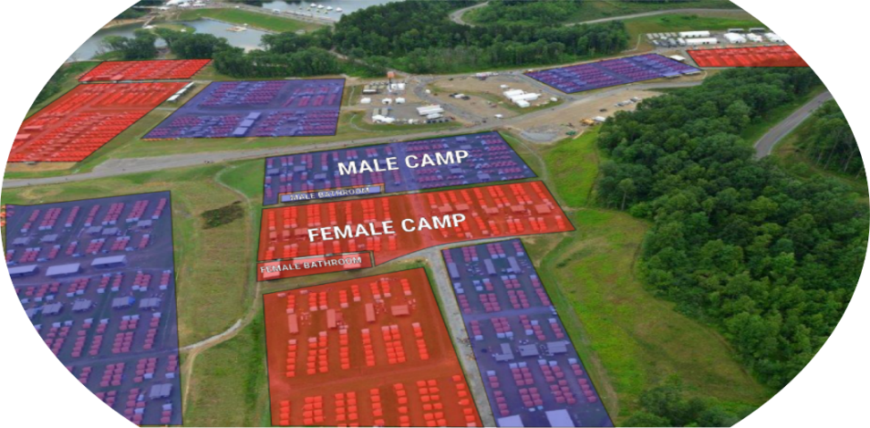
- Two youth participants will be rooming together in one tent. Youth sharing tents must be no more than two years apart in age per the BSA Barrier to Abuse.
- Youth participants 18-20 years of age are considered adults and will not be housed with anyone under 18.
- Adult leaders will have individual tents based on 4 leaders per unit. For units with additional leaders, double occupancy will be required.
- Both the youth participant and leader tents will be dome-style tents with cots provided.
- All individual Scouting units will be preparing their meals in their assigned living area.
- There will be one headquarters area within each subcamp for assistance.
- There will be accessible medical facilities near each base camp.

Unit Campsite Configuration
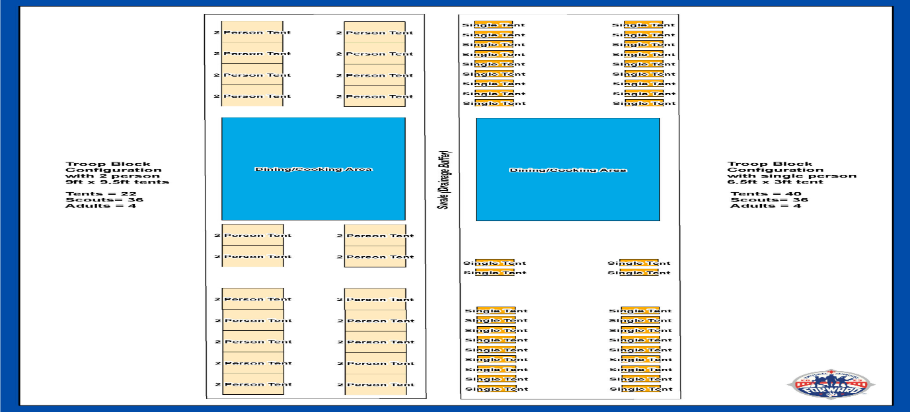
- Units will bring their own tents to the 2023 National Jamboree.
- The Summit Bechtel Reserve Campsite set-ups may have perimeter swale and must maintain a fire lane. Each unit must stay with their campsite configuration.
- As a reference: Past Jamborees had 22 – 9’x9.5’ floor diameters in their layout.
- The following tool can be used as a guide to make sure that your unit will have an enjoyable camping experience while at the 2023 National Jamboree.
- Be mindful that your unit will want to bring tent repair kits and possibly additional tents due to weather conditions that occur in West Virginia.

Base Camp and Sub Camp Operations
- There will be multiple participant base camps identified by a letter (A, B, C, D, E, F).
- Within base camps are subcamps.
- BSA Policy applies to all camping at the National Jamboree.
- Youth participants 18-20 years of age are considered adults and will not be housed with anyone under
- Adult leaders may be required to share tents based on campsite configuration.
- Both the youth participant and leaders will be provided cots. Cots are 76.75” L x 33.25”W x 18.25H.
- All individual Scouting units will be preparing their meals in their assigned living area. There will be one headquarters area within each subcamp for assistance.
- There will be accessible medical facilities near each base camp.

Transportation
All participants (youth and adult) are required to travel to and from the Jamboree with the WTAC contingent. The logistics of the Jamboree site are incredibly well designed. In fact, the Jamboree site becomes one of the largest populated “cities” in the state of West Virginia in 24 hours as 40,000 people enter the high adventure base and set up camp. The committee is currently working on the logistics of transportation and exact times will be announced at the Contingent Meeting in May 2023.

Lost and Found
To guard against the loss of valuables: Mark uniforms and personal equipment with your name and email or cell phone number. If you find an item at the jamboree that is not yours, please take the item(s) to the nearest Lost and Found area. Any items needing shipped will be done at the owner’s expense. Upon the completion of the Jamboree, unclaimed items will be donated to local charity or discarded.

Gear & Equipment
All personal gear will be carried by the participant from the bus stop to the campsite. This could be a distance up to 1 mile. Please pack accordingly. Gear will be limited to what can be packed in the contingent duffel bag. Following is a preliminary list of items each participant should bring:

Personal Gear
• Sleeping bag (lightweight in stuff sack with 30-degree rating is good)
• Eating kit (plate, bowl, and spork are adequate)
• Reusable lunch bag (Disposable plastic bags will not be provided.)
• Two 1-liter water bottles • Toiletry kit (keep it small)
• Two bath towels • Two hand towels
• Two washcloths

Clothing
• One complete field uniform (See note below) • Good, broken-in hiking boots
• Lace-up shoes (lightweight sports) • Rain gear (simple, lightweight)
• Scout headgear • One jacket or sweatshirt (synthetic is good)
• Two sets of sleep clothes • Seven pairs of underwear
• Flashlight • Sunscreen
• Non-aerosol insect repellent * Females: feminine hygiene products
• 4 or 5 Scout/jamboree T-shirts/polo/ activity shirts (antimicrobial synthetic is ideal)
• 5 or 6 pairs of hiking socks; 3 pairs of other socks
Note: Arrival Day, stadium show, Sunday religious observances, and departure day are uniform days; other times may be determined by your unit leader. Other days are Scout/ Jamboree T-shirts or activity shirts with uniform shorts/longs.

Optional
• Air or travel pillow • Swimsuit
• Water shoes • Sunglasses
• Solar camp shower (three-gallon)

Sustainability
The Summit has a network of tanks, pipes, and filters that serves as our greywater system. As a result of the greywater system and the ambient-temperature showers, the amount of water required per person has been reduced by nearly two-thirds. And by reusing our water the size of the wastewater system has been reduced by half. It is encouraging that Scouts and Scouters are finding inexpensive, renewable ways to heat the water for showers. We just ask that you remain respectful of the overall water-consumption goals on-site. If you are considering a solar camp shower, please limit yourself to three gallons or less in size. Your water resourcefulness will go a long way in making sure the Summit’s systems are not overstressed.

Cooking and Eating
Food issued to participants will be of top quality and there will be lots of it! All units will be cooking as a troop/crew for breakfast and dinner, not as individual patrols. Trail lunch supplies will be distributed with breakfast for participants to pack lunch and carry it with them as they leave their camping area for the day. Proper training in food preparation techniques prior to the jamboree will help ensure an enjoyable experience for all unit members. It is the responsibility of the assistant Scoutmaster or adviser in charge of physical arrangements to give oversight to the preparation and serving of meals within the unit.

Duties will include:
• Ensuring safe practices are followed in the handling and preparation of food
• Working through and with the youth leadership to train and oversee the tasks of picking up food and food supplies, food preparation, serving, and cleanup.
• Consulting with youth cooks regularly on the most effective ways to prepare daily food selections
• Meeting with the youth cooks and giving briefings on food preparation and safety precautions
• Overseeing cleanup operations after each meal

Menu
Youth and leaders attending the jamboree will be issued meals supplies from a pre published menu.

Cooking Equipment
The unit equipment package furnished by the jamboree will include propane stoves with the fittings necessary to use the provided tanks and fuel for all meal preparation. Under no circumstances should participants bring cooking appliances, fuel tanks, or fuel.

Special Diets
The Jamboree Food Team will aid Scouts, leaders, and staff who have special dietary requirements in the following ways: Food restrictions such as Kosher, Halal, Celiac and Nut allergies will be honored. During online registration, each youth, leader, and staff member will be asked specifically to indicate a need for a special diet. In addition, there are many Gluten-free and vegetarian choices in our menu’s. The information included in the menu documents address ingredients and notifications to assist all Jamboree participants in avoiding items that may cause allergic reactions or discomfort. Menus and ingredients will be included in contingent menu information. You may also opt to bring additional shelf stable supplements.
The Jamboree Food Team recognizes that there are many potential dietary restrictions as well as common diets (e.g., low-calorie, and low carbohydrate) and common food allergies (e.g., to gluten, citrus fruit, dairy, eggs, fish, nuts/ peanuts, and shellfish). Individuals will need to consider this and use the published information avoid such items in the campsite or their buffet choices in the staff dining halls.
In addition, remember that the Food Team cannot feasibly plan for all specific dietary needs of all persons attending the jamboree. Therefore, anyone with special food requirements for medical reasons (after medical permission to attend jamboree is granted), or personal dietary beliefs, must make their own arrangements to meet those needs by bringing nonperishable food with them—just as they would bring their own medications.

Medical Requirements
Weather conditions at the jamboree can range from being hot and humid during the day to mild temperatures in the evenings. Rain is more common at the Summit due to its location in the Appalachian Mountains. Jamboree activities are very strenuous. It is crucial that everyone arrive fit and prepared, and drink plenty of water while at the jamboree.

Physical Examination
All participants must submit certification of physical fitness on the official BSA Annual Health and Medical Record. Maintenance of good health in a jamboree camp is of utmost importance, and it is with this objective in mind that the following must be enforced:
• Participants will be expected to get a complete examination by a licensed health-care practitioner.
• A complete and current BSA Annual Health and Medical Record (Parts A, B, & C) must be hand signed by the physician and parent. This medical form, with copy of a health care insurance card (if applicable) should be provided to your unit leader and uploaded to the BSA national site ASAP. It is required that the examination take place not fewer than 30 days or more than 12 months before departure to the Jamboree.
• Participants will go through a medical screening prior to arrival. It is imperative that all medical forms are submitted by the published deadlines so that prior approval for participation occurs before you leave for the jamboree. In the event a participant is found medically unfit upon arrival at the Summit, he or she must return home at his or her own expense.

Immunizations
When attending Boy Scouts of America programs or activities that requires an Annual Health and Medical Record or specialty physical exam to be completed, it is required to have a current tetanus immunization.
The following immunizations are strongly recommended:
• Hepatitis A • Hepatitis B
• Diphtheria, pertussis • Meningococcal
• Polio • Measles, mumps, and rubella
• Varicella • Influenza

Exceptions to Immunization on Medical or Religious Grounds
If there is a medical or religious reason why you cannot comply with vaccination requirements, obtain a statement to that effect from a physician if it is an exemption on medical grounds. If you aren’t immunized due to religious reasons, you must also provide a statement to that effect that includes specific reasons, so it can be given full consideration by the Jamboree medical staff. These statements need to be submitted with the medical form. The immunization exemption request form can be found at https://filestore.scouting.org/filestore/pdf/680-451.pdf.

Physical Fitness—
Be Prepared! GO FORWARD WITH PHYSICAL FITNESS Participation in the National Jamboree at the Summit Bechtel Family National Scout Reserve is a physically demanding experience. The layout, grade and elevation of the site requires substantial walking as part of everyone’s daily schedule. Several activities require more stamina and fitness too—think climbing, rappelling, rafting, mountain biking, and skateboarding. It is essential that all participants and staff are prepared for the physical demands of the Summit prior to arrival.
Going Forward at the ’23 Jamboree will require one to be physically fit!
Obesity and being overweight have been shown to increase the likelihood of certain diseases and other health problems: hypertension, heart attack, dyslipidemia, and stroke. Anyone who is obese and has multiple risk factors for heart and lung disease would be at much greater risk of an acute health event imposed on them by the environmental stresses of the Summit. Our goal is to prevent any serious health-related event from occurring and ensuring that all our participants and staff are “physically strong.”
There are multiple” co-morbidities” which should be taken into account as decisions are made about an individual’s inclusion in the jamboree. Individuals with a history of any of the conditions listed below should consult their healthcare provider to see whether participating in the Jamboree could exacerbate their condition.
These applicants may also be requested to provide further documentation, including cardiac testing, pulmonary testing, or further information from their physician to ensure the applicant’s ability to participate.
• Obesity • Tobacco Use • High Blood Pressure
• Diabetes mellitus • Dyslipidemia • Prior heart attack
• Coronary angioplasty/stent • Coronary artery surgery • COPD
• Family history of premature (before age 55) heart disease
• Sleep apnea requiring CPAP or BiPAP
• Prior stroke or transient ischemic attack (TIA)
Accordingly, it is the policy of the 2023 National Jamboree that all individuals:
1. Provide their healthcare provider with the Summit High-Adventure Risk Advisory to Health Care Providers and Parents.
2. Submit a completed BSA AHMR signed by their healthcare provider

Medications
Leaders need to treat youth medications as they would on any unit campout or when attending summer camp. Medications are to be secured and dispensed by the unit’s Leaders throughout the jamboree, as well as while traveling to and from the Summit. It is required that the unit bring a small lock box to store these medications.
Medications needing refrigeration while at the jamboree can be stored at the medical service location nearest your assigned camping location. While you are traveling to and from the jamboree, you will need to keep these medicines at their required temperatures by using a small cooler, etc., if needed.

Staff a.k.a. Jamboree Service Team
Please spread the word to adult leaders you admire in Scouting – the jamboree needs as many volunteer staff members as possible. This is a great way for adults, both new and experienced, to enjoy the fun of the jamboree. Jamboree Service Team members will have the opportunity to serve in numerous assignments at the Jamboree. Jamboree Service Team members will be needed in many of the jamboree groups and services listed on the service team application. The list of positions and volunteer information is published on the national jamboree website:
https://jamboree.scouting.org/jamboree-service-team/

Statement of Understanding
All participants (youth and leaders) are selected to represent their local councils based on qualifications in character, camping skills, physical and personal fitness, and leadership qualities. Therefore, all adult and youth participants and their parents or guardians are asked to read the Code of Conduct and Statement of Understanding as a condition of participation.
It is with the further understanding that serious misconduct or infraction of rules and regulations may result in expulsion (at the participant’s own expense) from the jamboree or during the jamboree tour. Each participant is responsible for his or her own behavior, and only, when necessary, will the procedure be invoked to send a participant home from the jamboree.

Code of Conduct
The unit’s adult leaders are responsible for the supervision of its membership, maintaining discipline, security, and the Jamboree Code of Conduct.
- Leaders will be guided by the Scout Oath and Scout Law and will obey all U.S., local, and state laws.
- I promise to obey the Scout oath and law.
- I will be Scout-like in how we act and treat others.
- I will set a good example by keeping myself neatly dressed and presentable.
- I will attend all scheduled programs and participate as required in cooperation with other unit members and leaders.
- In consideration of other unit participants, I agree to follow the bedtime and sleep schedule of the unit.
- I will be responsible for keeping my tent and personal gear clean and neat and labeling all personal gear.
- I will adhere to all recycling policies and regulations. I will not litter.
- I understand that the possession or consumption of alcoholic beverages or illegal drugs is prohibited at The Summit.
- I understand that serious and/or repetitive behavior violations, including cheating, stealing, dishonesty, fighting, and cursing, may result in expulsion from The Summit or serious disciplinary action and loss of privileges.
- I understand that gambling of any form is prohibited.
- I understand that possession of lasers of any type and possession or detonation of fireworks is prohibited.
- I will demonstrate respect for The Summit and unit property and be personally responsible for any loss, breakage, or vandalism of property because of my actions.
- Neither the unit leaders nor the Boy Scouts of America will be responsible for the loss, breakage, or theft of personal items. I will label all my personal items and check items of value at the direction of unit leaders. Theft will be grounds for expulsion.
- I will obey the safety rules and instructions of all supervisors and staff members.
- I understand that hazing has no place in Scouting; nor do running the gauntlet, belt lines, and similar acts of physical punishment.
- I understand that participants may only bring items specified on the equipment list provided.
- I understand that I can be sent home for bullying, cyberbullying, horseplay, fighting, stealing, off-color jokes, remarks or conduct unbecoming of a Scout, harassment of any kind – sexual, religious, race, cultural, national origin, disability, etc., being a “peeping tom”, being in an off-limits area and/or repeated failure to follow instructions.
Violation of this Code of Conduct, or any other conduct deemed to be inconsistent with the values of Scouting, may result in expulsion from The Summit at the participant’s own expense and could result in revocation of BSA membership.

Youth Protection
All registered adults must have current BSA Youth Protection Training. This means all participants 18 years of age and older who are registered in Venturing, Exploring, Sea Scouting, or as an adult volunteer must have current Youth Protection Training.
Because of the great concern the Boy Scouts of America has for the issue of child abuse within society, the Youth Protection program has been developed to help safeguard both our youth and adult members. Adult BSA Registration requires verification of Youth Protection Training. All adults participating in the National Jamboree must be registered.
Youth Protection Training and documentation are available online at www.scouting.org or www.my.scouting.org.

Commitment to Safety
The safety and health of our youth, volunteers, service team, and employees is a key component of the 2023 National Jamboree experience. Youth develop traits of citizenship, character, fitness, and leadership during age-appropriate events when challenged to move beyond their normal comfort level and discover new abilities. In doing so, it is essential that risks are identified and mitigated.
The 2023 National Jamboree program, activities, and events integrate many safety features. However, no policy or procedure will replace the review and vigilance of trusted adults and youth leaders at the point of program, activities, and event execution.
In order to promote and secure a safe and healthy 2023 National Jamboree environment, all leaders are asked to: Know and execute the BSA program as contained in appropriate jamboree publications and the Guide to Safe Scouting. Properly plan pre/post jamboree tours, activities, and events and become familiar with the Sweet 16 of BSA Safety. Set the example for safe behavior and equipment use during all programs, activities, and events. Engage and educate participants in discussions about hazards and risks, their identification, and mitigation. Together we will ensure the 2023 National Jamboree provides an exciting and safe experience for everyone.

Unit Organization

Scouts BSA Organization
Unit leadership responsibilities and duties will be assigned by the Scoutmaster/Advisor/Skipper. Units with Adult participants more than the Key 4 leaders will have an opportunity to support the Jamboree Service team.

Adult Participant Roles
Scoutmaster
The personal leadership of the Scoutmaster is one of the most important factors in effective administration of the jamboree. Good judgment and sensible controls will help make exercising many of the camp regulations unnecessary.
• Serves as the executive officer of the Troop.
• Maintains policies and coordinates efforts of assistant Scoutmasters, Unit Care Provider and Chaperones.
• Assists in conducting jamboree promotion rallies and in recruiting individual Scouts to attend the Jamboree
- Leads participants in pre-jamboree training.
- Works through assistant Scoutmasters, Unit Care Provider, Senior Patrol Leader, and Patrol Leaders to ensure fulfillment of their duties.
- Accompanies troop to and from the Jamboree.
- Is personally responsible for the health, safety, and morale of the troop. By their example, serves as a role model for others to follow.
- Is always responsible for the proper behavior and conduct of the members of troop. Receives a report from the senior patrol leader on bed check each evening after taps and reports those present, accounted for, or missing to the designated subcamp staff member.
- Cooperates with subcamp leadership at all times.
First Assistant Scoutmaster (Troop Activities)
- Serves as the troop leader in the absence of the Scoutmaster.
- Assists in conducting jamboree promotion rallies and in recruiting individual Scouts to attend the Jamboree.
- Participates in pre-jamboree training.
- Works with the Assistant Senior Patrol Leader in administering troop operations.
- Is responsible to the Scoutmaster for program and activities of the troop.
Second Assistant Scoutmaster (Physical Arrangements)
- Assists in conducting jamboree promotion rallies and in recruiting individual Scouts to attend the Jamboree.
- Participates in pre-jamboree training.
- Responsible to the Scoutmaster for the troop’s physical arrangements. Works with the troop quartermaster in the issuance of supplies.
- Arranges directly with the subcamp repairs and maintenance officer for supplies. Working through and with the quartermaster and senior patrol leader, trains and oversees the troop’s tasks of drawing food and food supplies, preparation and serving of food, and cleaning up.
- Consults regularly with troop cooks on the most effective ways to prepare daily food selections.
- Meets daily with the troop cooks, giving briefings on food preparation and safety precautions.
- Oversees cleanup operations after each meal.
- Is responsible for the care and neat appearance of all equipment.
- Is responsible for transportation of personal baggage to and from the jamboree.
Third Assistant Scoutmaster (Scheduling and Records)
- Assists in conducting jamboree promotion rallies and in recruiting individual Scouts to attend the Jamboree.
- Participates in pre-jamboree Training.
- Works with the troop scribe in the handling of troop records and the scheduling of troop participation in jamboree activities.
- Encourages Scout news correspondents to send news to their hometowns. Maintains a relationship with the National Jamboree Connected Experience.
- Maintains the general morale of the troop, including the distribution of mail and other communications
- Responsible for training and providing oversight for sustainability, recycling, and trash management within the unit.
- Works with the quartermaster to continue the sustainability effort of the BSA by leading the recycling effort within the campsite.
Unit Care Provider
If the unit has only 4 Adult leaders. The Unit Care Provider must be one of the Unit Leaders (SM or ASM).
- The Unit Care Provider is required to hold either current Wilderness First Aid and CPR certificates or a current healthcare license (MD, DO, APRN, RN, PA, Paramedic, EMT).
- Provides for the safety and well-being of each unit member by:
- Reviewing their AHMR and maintaining a binder/file containing all of the Unit’s AHMRs.
- Maintaining the Unit First Aid Kit and providing first aid treatment within the unit
- Overseeing administration of required medications.
- Collects and prepares the Unit First Aid Kit contents as defined by the Jamboree Medical Officer.
- Participates in Pre-Jamboree Training.
- Will be encouraged to support the Jamboree Service Team in a vocational appropriate function through an exclusive opportunity while at the Jamboree. (Details will be announced in 2023).

Youth Participant Roles
Senior Patrol Leader
- Serves as the top youth leader of their Troop.
- Maintains information on the whereabouts of Troop members.
- Works directly with the Scoutmaster in administering Troop operations
- Through the patrol leaders, is responsible for the appearance of Scouts regarding cleanliness and proper uniform.
- Maintains schedules within the troop camp covering reveille, meal hours, and other special assignments received from subcamp staff.
- Organizes all formations of the troop.
- Makes bed checks at taps each evening and reports and accounts for all members of the troop to the Scoutmaster
Assistant Senior Patrol Leader
- Acts in the absence of the senior patrol leader and assists the senior patrol leader as directed.
- Works with the first assistant Scoutmaster in administering troop activities.
Quartermaster
- Is responsible for troop equipment and supplies.
- Works with the second assistant Scoutmaster for storage and issuance of all equipment and supplies belonging to the troop or issued to it at the jamboree.
- Will continue the sustainability effort of the BSA by leading the recycling effort within the campsite.
- Maintains an inventory of all equipment and supplies and is responsible through the second assistant Scoutmaster for the return in good repair of all equipment to the assigned subcamp staff member.
Scribe
- Is the custodian of all troop records.
- Works directly with the third assistant Scoutmaster in handling registration procedures and in keeping such records as required.
- Keeps the log of the troop and carries out other duties as may be assigned by the Scoutmaster
- Assists the third assistant Scoutmaster in registering and helping Scout news correspondents.
Chaplain Aide
- Helps with troop program planning, considering religious holidays and including religious observances during troop activities and traveling to and from the jamboree.
- Assists in planning and carrying out troop religious activities.
- Informs troop members about the religious emblem program of their faith and how it is earned.
- Encourages troop members to live up to the ideals of the Scout Oath and Scout Law.
Historian
- Keeps a logbook about the troop’s meetings and activities.
- Keeps a scrapbook of newspaper clippings and digital media about the troop’s activities. Collects images from other troop members to make a photo album of the troop’s activities.
Patrol Leader
- Receives assignments for patrol members from troop leaders.
- Informs members of the patrol of assignments and sees that they are carried out.
- Sees that patrol tents, equipment, and the area around the tents are kept neat, clean, and orderly.
- Knows the whereabouts of every member of the patrol.
- Manages the dynamics of the patrol to the point where, when called upon by the senior patrol leader, they can report and account for full membership
Assistant Patrol Leader
- Acts in the absence of the patrol leader.
- Assists the patrol leader as directed

Postal Service
Mail will be delivered to the subcamp headquarters in the early afternoon for pickup by the designated unit leader for each subcamp unit
The Jamboree mailing address is:
First and last name of the Scout/Scouter + Troop/Crew No. (i.e., A213)
2023 National Jamboree
92 SBR 2
Mount Hope, WV 25888
Use your home address as the return address on the envelope or parcel.

Trading Posts & Retail
There will be a trading post operating in a centrally convenient location at the jamboree. The following services and types of items will be available at the National Jamboree for purchase: Souvenirs. An attractive line of branded jamboree souvenirs. Sundries. An assortment camp-life consumables or replacement items. Snacks: Drinks, ice cream, candy, and light meals will be available at a variety of locations. Acceptable payments include cash or debit/credit cards.
A majority or prices charged for merchandise and services at Jamboree trading posts will be similar to the prevailing prices of comparable merchandise in cities and towns in the area.

Telephone Communications
As the frequency of cell phone usage increases, telephone usage is becoming less of an issue. There are multiple cell phone towers on the property, plus back-up capabilities in case of emergencies. All emergency phone calls must be made to a specific number that will be sent to councils before the jamboree. Messages will then be delivered to the person’s subcamp headquarters. Persons will then return calls from predesignated locations throughout the site. It is important that someone be appointed to receive emergency calls that may come into the council service center during the jamboree. Council service centers must have on file the names, addresses, and phone numbers of parents or guardians of each youth member and spouse or relative of each unit leader and staff member to contact in case of an emergency. The home and business telephone numbers must also be on file. Each council is asked to appoint someone to be responsible for handling emergencies day and night during the jamboree. Your jamboree unit leaders must have the name and phone numbers of the key persons to contact in the council.

